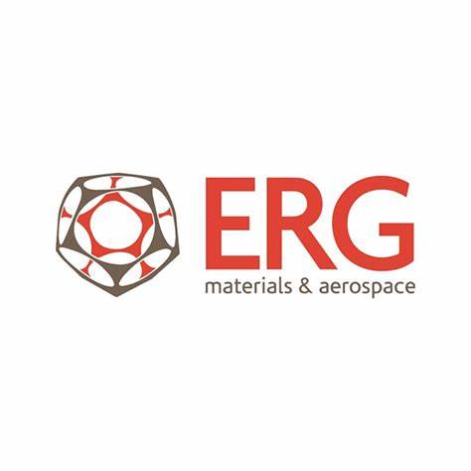

ERG Aerospace Corporation

White Paper

Duocel® Foam for Bird Strike Mitigation in Aerospace Structures

ERG Aerospace Corporation
www.ergaerospace.com
Contact: info@ergaerospace.com

1.0 Executive Summary
Bird strikes remain a persistent hazard for both manned and unmanned aircraft, particularly during low-altitude operations. This white paper outlines the strategic use of ERG Aerospace's proprietary Duocel® foam for bird strike mitigation in vulnerable structural areas. By leveraging the unique energy absorption, structural integrity, and lightweight properties of Duocel, aerospace designers can enhance survivability without compromising weight or aerodynamics in critical zones.

2.0 Introduction
Bird strikes can severely damage aircraft components, posing risks to flight safety, mission effectiveness, and platform integrity. Traditional mitigation relies heavily on composite skins and thick resin-based laminates, which add mass and reduce design flexibility. Duocel® foam offers a novel solution: an open-cell metal or ceramic foam that absorbs high-velocity impact energy while maintaining low weight and structural resilience. Additionally, by replacing or supplementing resin-based solutions, Duocel enables significant weight savings, which can translate to improved fuel efficiency, payload capacity, and mission endurance.

3.0 Material Overview: Duocel® Foam
Duocel® is an engineered foam structure composed of a three-dimensional network of solid ligaments forming open-celled pores. Unlike closed-cell foams, Duocel® features fully interconnected porosity, enabling air or fluid to pass through the structure during dynamic events such as compression. The solid ligaments provide excellent mechanical strength and reliability, while the open-cell geometry ensures efficient energy dissipation and deformation under load. This combination makes Duocel® exceptionally well-suited for high-performance, three-dimensional energy absorption applications that demand lightweight, compact, and structurally efficient materials—particularly in aerospace, defense, and advanced mobility systems.
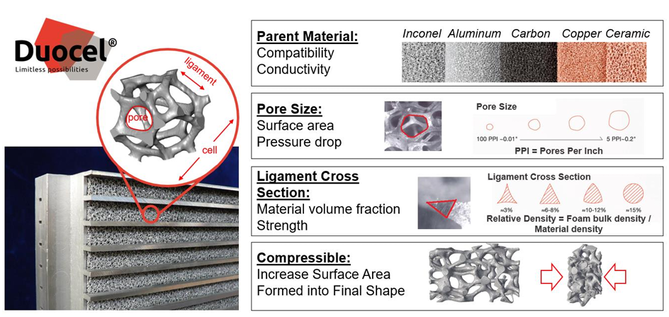
Figure 1 outlines the material structure highlighting key properties of the material.
Figure 1. Duocel Properties
Duocel® foam is available in a wide range of porosities and densities to tailor performance to specific applications. For example:
- 10 PPI (pores per inch): ~5% relative density, ideal for high energy absorption
- 20 PPI: ~7-8% relative density, balance of strength and crush resistance
- 40 PPI: ~10-12% relative density, more structural support with finer structure
These variations allow Duocel to be precisely engineered for directional or multi-axis impact profiles, making it suitable for complex three-dimensional energy-absorbing requirements in aircraft structures.
4.0 Design Integration Points for Bird Strike Protection
Duocel® is typically configured for bird strike protection using a design optimized for impact absorption and weight efficiency. The most common setup includes:

Aluminum 6101-T6, 40 Pores Per Inch, 5-15% denisty — selected for its excellent strength-to-weight ratio, corrosion resistance, and consistent mechanical performance under dynamic loading

This configuration enables Duocel® to serve as an effective energy-absorbing core in leading edges, nosecones, and fairings where bird strikes pose a serious threat to mission capability and structural integrity. Examples of integration points for Bird Strike include:

Nose Structures (Non-Radar-Bearing)
Use: Crush layer inside nosecones of UAVs, missiles, and drones
Benefit: Absorbs impact and protects sensitive payloads or avionics

Wing and Stabilizer Leading Edges
Use: Embedded behind composite skins in high-speed aircraft
Benefit: Absorbs bird strike energy without compromising aerodynamic contour

Engine Nacelle Cowling
Use: Internal liners around lower nacelle structures
Benefit: Protects casing from indirect bird impacts near inlets

Protective Bumpers on sUAS
Use: Wrap-around barriers or sacrificial skirts
Benefit: Increases resilience for low-cost, reusable UAS platforms
Strike-Resistant Backing Layers (Non-RF Regions)
Use: Located behind radar-transparent composite outer skin
Benefit: Provides secondary bird impact protection while preserving RF function (only in areas not within radar aperture)

Manned Aircraft (Commercial and Military)
Duocel can be integrated into forward fuselage, wing roots, or empennage for added safety without significant weight penalties. Weight savings compared to resin-based composites can contribute to lower fuel burn and extended range.

VTOL and eVTOL Platforms
Foam used in fuselage exteriors and landing struts improves crashworthiness and bird impact tolerance. Supports urban air mobility requirements for safety and redundancy.

Space Launch Systems and Reentry Vehicles
In protective shrouds or interstage segments, Duocel mitigates high-velocity debris or bird strikes during ascent or staging.
6.0 Application Example: UAV Nosecone Structure
Customer is seeking enhanced impact protection with minimal weight increase, no loss of aerodynamic profile, and retention of internal component integrity during high-speed bird strikes.
Layer Stack:
1. Outer aerodynamic composite fairing
2. Duocel® aluminum foam energy-absorbing layer
3. Internal electronics housing or sensor mount
7.0 Engineering Support
ERG Aerospace Corporation maintains in-house mechanical testing capabilities, including access to stress-strain curve measurement systems and a dedicated impact testing lab. These facilities enable precise characterization of Duocel® foam under real-world load conditions, including high-strain-rate impacts and compressive or tensile failure modes. By generating accurate mechanical profiles across a range of porosities and materials, ERG supports customers in selecting and optimizing foam configurations for specific structural and energy absorption requirements. This testing infrastructure also allows rapid prototyping and qualification of custom foam solutions for aerospace, defense, and industrial applications.

8.0 Conclusion
Duocel® foam provides an innovative solution for bird strike mitigation in aerospace platforms, particularly where lightweight impact resistance is critical. By integrating Duocel strategically in non-RF and structural areas, aerospace designers can improve survivability, reduce maintenance costs, and enhance mission assurance. The ability to tune porosity, density, and foam orientation allows Duocel to address a broad range of energy absorption needs, including tailored performance for three-dimensional impact loading. The weight savings over traditional resin-based or composite laminates can also drive meaningful gains in fuel efficiency, maneuverability, and system longevity, especially for long-endurance or rapid-response aircraft.

